 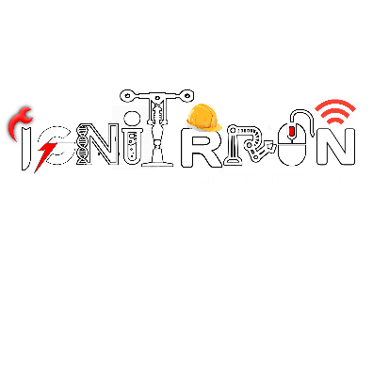

**IGNITRRON 2021-2022 CLUB STUDENT COORDINATORS**

|  |  |  |
| --- | --- | --- |
| S.NO | CLUB NAME | STUDENT COORDINATORS |
| NAME | |
| 1 | BUSINESS CLUB | Ravi Varma(IV CSE) | |
| Mohammed Sameer(III EEE) | |
| 2 | ELECTRONICS CLUB | S.Vinith kumar(III ECE) | |
| S.M.Kiruthiga(III ECE) | |
| 3 | FILM CLUB | Amar(III ECE) | |
| Thirumoorthi(III ECE) | |
| 4 | AVIATION & ROBOTICS CLUB | A S Kaviya(II ECE) | |
| Madhavan(II ECE) | |
| 5 | SOFTWARE DEVELOPMENT CELL | Rajesh kumar S(III CSE) | |
| Rajalakshme (III CSE) | |
| 6 | HAM CLUB | Ajay Kumar(IV MECH) | |
| Pooja(IV ECE) | |
| 7 | MATH CLUB | Indrish (IV EEE) | |
| Naveen (III CSE) | |
|  | |
| 8 | SCIENCE CLUB | Lingatharani (IV BME) | |
| Lakshmi Priya (III CSE) | |
| 9 | SPACE CLUB | A,Amal Kumar(IV CHEM) | |
| S.B.Harine(III CHEM) | |
| 10 | QUIZ CLUB | Abirami(IV BME) | |
| Srivatsa –II AI&DS | |